WHITE - MS SQL Server DB Transactional Replication Set Up Instructions

Current architecture diagram identifies 3 key servers in this replication setup. Distributor (server #2 in diagram below) is the major “work horse” of this replication procedure and it is designed to sits inside of PHSA Domain/Network. Publisher (server #1 or any other of the servers left from ENG) is the source of this replication and it resides in HA’s domains/networks. Subscriber (server #3 in diagram) is the ultimate destination of replicated data and will be used as a source for future BI processing.

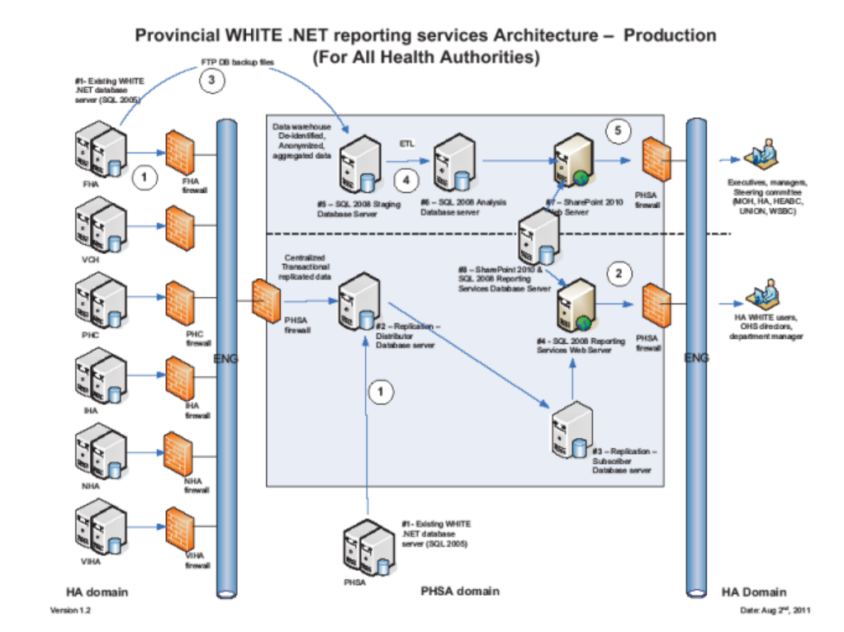

For the purpose of running this replication with Windows integrated security, it is necessary to create 3 windows accounts which will be used to complete installation procedure and run following agents:

* Log-reader agent (on Distributor and Publisher)

* Snap-shot agent (on Distributor and Publisher)

* Distribution agent (on Distributor and Subscriber)

Name of the scripts is named by the server name where has to be executed. Number after underscore represents its place in the sequence.

Run sequence of the scripts:

1. Distributor_1

This script has to be executed only once since it will be only one distribution server.

2. Distributor_2

Need to be executed as many times as there are publishers. Each publisher will have its own distribution database. After script is executed, grant snap-shot, log-reader and distribution accounts to become a member of db-owner role in each distribution database.

3. Distributor_3

Before this script is executed, need to create Distribution Working Folder on Distributor, where snap-shot account will have write permission. Script needs to be executed as many times as there are publishers.

4. Publisher_4

This script has to run for each published database.

5. Publisher_5

This script has to run for each published database.

6. Publisher_6

Before script is executed, grant log-reader account to become a member of db-owner role for publishing database. This script has to run for each published database.

7. Publisher_7

This script has to run for each published database.

8. Publisher_8

Before script is executed, grant snap-shot account to become a member of db-owner role for publishing database. This script has to run for each published database.

9. Publisher_9

This script has to run for each published database. After this script is executed, check did snap-shot agent job was started on Distributer. If not, start it manually

10. Subscriber_10

This script has to run for each publishing databases. After script is executed, grant distributer account to become a member of db-owner for subscribing database.

11. Publisher_11

This script has to run for each published database.

Replication recovery.

In the case that some of the servers, which participate in replication process is down, there is no specific procedure to recover it. Just make sure that server is back, up and running and replication process will pick up from the point where it stopped before the interruption.

In the case that Distributor down, publisher can continue to have normal regime of work while Subscriber will stay not replicated. As soon as Distributer is back, replication will be pushed to Subscriber.

If the Subscriber is down, Distributor will keep collecting all changes from Publisher and once Subscriber is back, Distributer will push these changes to Subscriber.

Same will happen if Publisher is down, Distributor and Subscriber will stay up and running, and being ready for changes from Publisher.

Adding triggers in every subscription db

After successful replication implementation there is a need to monitor user’s reporting permission changes in replicated environment. User’s reporting permissions are implemented using WHITE application and information is stored in two tables: “sys_users” and “sys_users_reports”.  For that purpose script “Publisher_12_triggers” has to be executed in every subscription db. In order to monitor existence of these triggers (after  each subscription re-initialization they will vanish), there will be a MS SQL job on subscription server, which will check existence of these triggers notify DBA in the case of their absence.

Publisher update

When WHITE application updates time come (new release) this is a procedure which needs to be followed:

a. Execute “drop_subscription” in publishing db.

b. Execute “drop_articles” in publishing db.

c. Allow WHITE support team to apply WHITE DB upgrades

d. Execute “9_Publisher_updated_4_White3” script in publishing db, located on the same folder as previous scripts.

e. Recreate a snapshot

f. Execute “Publisher_11” in publishing db.